**How to Access and Interact with *Demonstrations***

1. Download and install the free *CDF Player* (no need to enter email address)
   1. [demonstrations.wolfram.com/download-cdf-player.html](http://demonstrations.wolfram.com/download-cdf-player.html)
2. Find the *Demonstration*
3. Three options for interacting
   1. Download the CDF file: click “Download Demonstration as CDF” on the right and open with the *CDF Player* (you will not be able to interact with it if you open a CDF file in *Mathematica*)

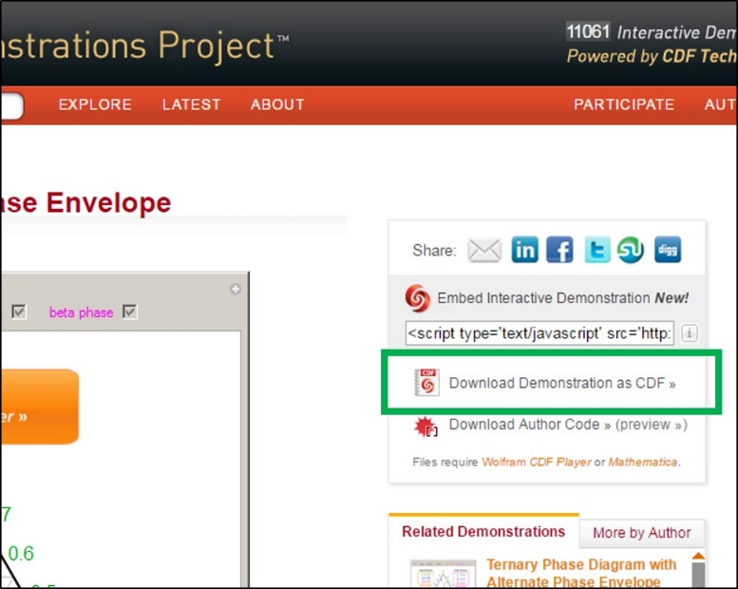

* 1. Download the notebook: If you have *Mathematica*, click “Download Author Code” on the right and open with *Mathematica*

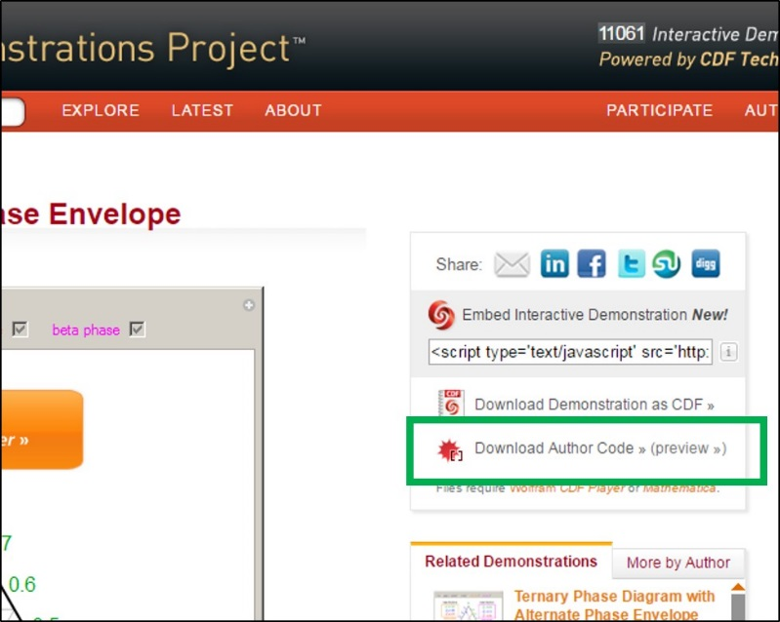

* 1. Interact in your browser: no need to download a file, interact with the *Demonstration* directly in your browser. This method may not work.